Access Tools and Support Site on Homepage Use Case
NCIA

Last Revised: 6/12/08
Produced by: NCIA Team
Document Approvals
The list contains the name and contact information for the core project team and any key stakeholders who have an interest in the success of the project. An “S” identifies persons responsible for approval from the stakeholder groups. Sign off of the document would be required when a decision is made not to take action for defined gaps.

S | Name | Role
S | Anand Basu | NCICB Engineering Manager
 | David Palmer | Project Manager
 | Jennifer Zeng | Technical Lead
 | Larry Holeman | Requirements Analyst
S | John Freymann | Customer Liaison
S | Anand Basu | NCICB Engineering Manager

Revision History
When you make a change to a document, you must add an entry to this Revision History table and you must manually type the Last Revised Date on the front cover.

Date | Version | Description | Revised by
06/13/2008 | 1 | NCIA welcome/login page and NCIA welcome/home page. | Larry Holeman
Copyrights and Trademarks
© Copyright 2008 by NCICB, caBIGTM. All rights reserved.

References
Requirement statements
https://gforge.nci.nih.gov/plugins/scmsvn/viewcvs.php/trunk/docs/requirements/Requirements%20Statements.doc?root=ncia&view=log
Scope Document
Table of Content
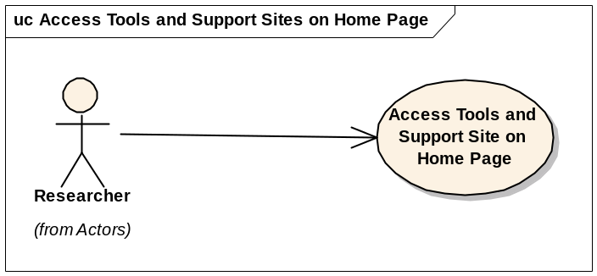
- Use Case – Access Tools and Support Sites from Home page
- Brief Description

NCIA provides the cancer research and medical community, industry, and academia access to imaging archives that can be used for many purposes, including the potential to assist in the development and validation of analytical software tools.
This use case identifies and describes the functions of the NCIA Welcome/Login Page and the NCIA Welcome/Home Page. NCIA is accessible at https://imaging.nci.nih.gov. In the Welcome/Login page that opens, you can perform the following tasks:
- Learn the basics about NCIA by reading the welcome page introduction
- Open a window that provides links for downloading DICOM viewers
- Open Quick Links to websites relevant to the goals and tasks of NCIA.
- Register for a new account
- Log into NCIA
The NCIA welcome/home page that opens after login displays several panels and menu bars and provide the following major functions that are described in the Search for Images use case:
- Search Images
  - Simple search
  - Advanced Search
- Remote Search
- Manage Data Basket
- Primary Actors
Researcher
- Pre-Conditions
Access to NCIA website
- Basic Flow of Events
- This Use case starts when a researcher navigate to the NCIA home page.
  - The system shall determine the type and version of the browser being used before accessing the NCIA home page.
  - If the browser is not supported by NCIA, the system shall display a webpage with a message indicating that the browser is not supported, which includes the information on the supported browsers and version.
  - The user shall be denied access to the NCIA home page without a supported browser.
- NCIA shall display several options from the Home Page Menu Bar.
- NCIA shall display several options from the Home page Left sidebar.
- NCIA shall display additional variety of options on the welcome/home page.

- Data

NCIA supported browsers

Message Text for unsupported browsers
The browser you are using is not supported by NCIA. Please update your browser before accessing this site.

As of February 8, 2008 the NCIA System supports the following web browsers and versions.
- Internet Explorer 6.0 and above.
- FireFox 2.0 and above

Security Page

Security Page
a. | The system displays a security alert with the message “You are about to leave a secure Internet connection. It will be possible for other to view information you send. Do you want to continue?”
b. | The User may click a box indicating “In the future, do not show this warning”
c. | If the researcher clicks more information, a pop-up window is displayed with a message “Entering a non-secure website from a secure website’ with a description.
d. | If the researcher clicks no, the researcher is returned to the page containing the links.
e. | If the researcher clicks yes to continue, the researcher is provided the tool’s homepage as a popup window.
f. | The researcher is able to navigate the selected tool while the NCIA homepage remains in the background.
g. | The researcher may exit the tool, removing the popup frame, and return to the NCIA Homepage.

Home Page Menu Bar
Option | Description
Home | Returns you to the NCIA Home page
Search Images | Displays the Simple Search page
Remote Search | Displays the Search Remote Sites page. This function is available only when NCIA is configured for remote image sites.
Manage Data Basket | Displays the My Data Basket page
Help | Displays a separate online Help window
Logout | Logs you out of NCIA and returns you to the NCIA home page

  - Home Page Left Sidebar
Option | Description | Links
DICOM Image Viewers | ImageJ link: | http://rsb.info.nih.gov/ij/
DICOM Image Viewers | FusionViewer link: | http://fusionviewer.sourceforge.net/index.html
DICOM Image Viewers | DicomWork link: | http://dicom.online.fr/
DICOM Image Viewers | OSIRIX link: | http://homepage.mac.com/rossetantoine/osirix/
DICOM Image Viewers | 3dSlicer link: | http://www.slicer.org/
DICOM Image Viewers | DCEMRI link: TBP | TBP
Quick Links | View the NCIA User’s Guide | https://imaging-dev.nci.nih.gov/ncia/faces/HTML/help/NCIA_Users_Guide.pdf
Quick Links | National Cancer Image Archive portal page | http://ncia.nci.nih.gov/ncia
Quick Links | Click the NCI Home link to navigate the National Cancer Institute homepage | www.cancer.gov
Quick Links | Click the NCICB link to NCI Center for Bioinformatics homepage | . http://ncicb.nci.nih.gov
Quick Links | Click the NCI caBig link to NCI Cancer Biomedical Informatics Grid Home Page. | https://cabig.nci.nih.gov
Quick Links | link to Cancer Imaging Program | http://imaging.cancer.gov
Quick Links | the link to Center for Bioinformatics | http://ncicb.nci.nih.gov/
Quick Links | link to national Institute of Biomedical Imaging and Bioengineering | http://www.nibib.nih.gov
Quick Links | RSNA link to Radiological Society of North America | www.rsna.org
My Data Basket | View Content | Displays the My Data Basket page
My Queries | View Saved Queries | Displays the saved queries page
My Queries | View Query History | Displays the query history page
Tools | Change password | Displays link to change your password
Tools | QC Tool | Allows a curator to evaluate a submission and assign QC status
Tools | Upload Curation Data | Provides the means to upload and parse an annotation spreadsheet.
Tools | Verify Submission | Verifies an image submission and its status through a report.
Central panel | Search Images | Displays the Simple search screen
Central panel | Simple search | Displays the Simple search screen
Central panel | Advanced search | Displays the advanced search screen
Central panel | Remote Search | Displays the remote site screen
Central panel | Manage Data Basket | Displays the My Data Basket page
Bottom menu bar | Contact us | Displays and email addressed so you can email questions to NCICB application supportncicb@pop.nci.nih.gov
Bottom menu bar | Privacy Notice | Displays the Health and Human Services (HHS) Privacy policy notice.
Bottom menu bar | Disclaimer
Bottom menu bar | Accessibility
Bottom menu bar | Support
Right hand Panel | NCIA Updates | Displays the last date and time visible images were made available. This date reflects the last update of any images and does not consider whether you have access to them.
Right hand Panel | NCICB Application Support | Displays phone numbers to contact NCICB Application Support.

